**UserInterface Design**

**Software used: Visual Studio 2008 ultimate**

**Asp.net Coding.**

* Home page contain navigation
* Artist page
* Song page
* User page

**CSS**

* Home page

**Xml**

* Advertisement.

**1.Home page contain navigation**

Home page code are given below with the screenshot.

<%@ Page Language="C#" AutoEventWireup="true" CodeBehind="home.aspx.cs" Inherits="songalbum.home" %>

<!DOCTYPE html PUBLIC "-//W3C//DTD XHTML 1.0 Transitional//EN" "http://www.w3.org/TR/xhtml1/DTD/xhtml1-transitional.dtd">

<html xmlns="http://www.w3.org/1999/xhtml">

<head runat="server">

<title></title>

<link href="home.css" rel="stylesheet" type="text/css" />

</head>

<body>

<div class="jumbotron text-center">

<h1>Album Songs</h1>

</div>

<form id="form1" runat="server">

<div id = "menu">

<ul>

<li><a href="home.aspx">Home</a></li>

<li><a href="#">Top 10</a>

<ul>

<li><a href="#">Artists</a></li>

<li><a href="#">Songs</a></li>

</ul></li>

<li><a href="#">Add New</a>

<ul>

<li><a href="Artist.aspx">Artists</a></li>

<li><a href="Songs.aspx">Songs</a></li>

</ul></li>

<li><a href="rating.aspx">Rating</a></li><br /><br /><br />

</ul>

</div>

<div>

<asp:ScriptManager ID="ScriptManager1" runat="server" />

<asp:UpdatePanel ID="up1" runat="server">

<Triggers>

<asp:AsyncPostBackTrigger ControlID="Timer1" EventName="Tick" />

</Triggers>

<ContentTemplate>

<asp:Timer ID="Timer1" Interval="4000" runat="server" />

<asp:AdRotator ID="AdRotator1" runat="server" AdvertisementFile = "~/ad.xml" Height="300px" Width="300px" Target=_top />

</ContentTemplate>

</asp:UpdatePanel>

</div>

</form>

</body>

</html>

In the above code I used ad rotator with some line of script.

<asp:ScriptManager ID="ScriptManager1" runat="server" />

<asp:UpdatePanel ID="up1" runat="server">

<Triggers>

<asp:AsyncPostBackTrigger ControlID="Timer1" EventName="Tick" />

</Triggers>

<ContentTemplate>

<asp:Timer ID="Timer1" Interval="4000" runat="server" />

<asp:AdRotator ID="AdRotator1" runat="server" AdvertisementFile = "~/ad.xml" Height="300px" Width="300px" Target=_top />

</ContentTemplate>

</asp:UpdatePanel>

**Screenshot:**

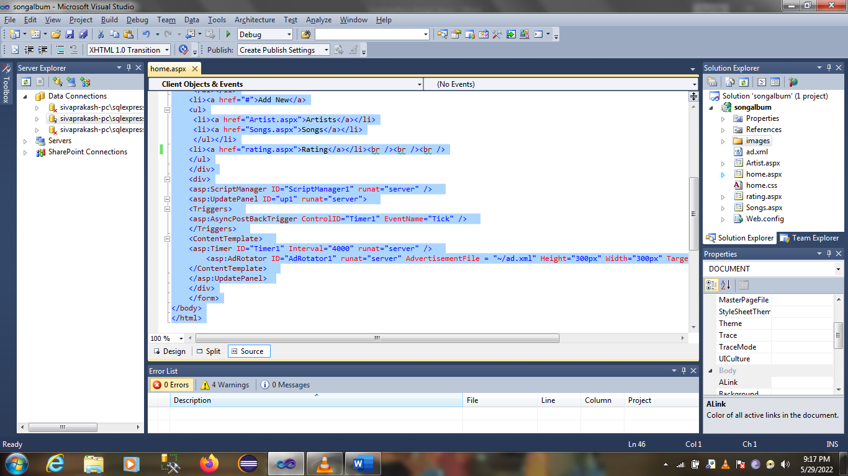

**Artist Page:**

Artist page codes are given below with the screenshot.

<%@ Page Language="C#" AutoEventWireup="true" CodeBehind="Artist.aspx.cs" Inherits="songalbum.Artist" %>

<!DOCTYPE html PUBLIC "-//W3C//DTD XHTML 1.0 Transitional//EN" "http://www.w3.org/TR/xhtml1/DTD/xhtml1-transitional.dtd">

<html xmlns="http://www.w3.org/1999/xhtml">

<head runat="server">

<link href="home.css" rel="stylesheet" type="text/css" />

</head>

<body>

<div class="jumbotron text-center">

<h1>Adding Artists</h1>

</div>

<form id="form1" runat="server">

<div id = "menu">

<ul>

<li><a href="home.aspx">Home</a></li><br /><br /><br />

</ul>

</div>

<div text-align: center;">

<td>

<asp:Label ID="Label1" runat="server" Text="Artist Name"></asp:Label>

<asp:TextBox ID="TextBox1" runat="server"></asp:TextBox><br /><br /><br />

</td>

<td>

<asp:Label ID="Label2" runat="server" Text="Date of Birth"></asp:Label>

<asp:TextBox ID="TextBox2" runat="server" TextMode="Date"></asp:TextBox><br /><br /><br />

</td>

<td>

<asp:Label ID="Label3" runat="server" Text="Biography"></asp:Label>

<asp:TextBox ID="TextBox3" runat="server" TextMode="MultiLine" Rows="20" Columns ="60"></asp:TextBox><br /><br /><br />

</td>

<td>

<asp:Button ID="Button1" runat="server" Text="Submit" onclick="Button1_Click" />

</td>

</div>

</form>

</body>

</html>

**Screenshot:**

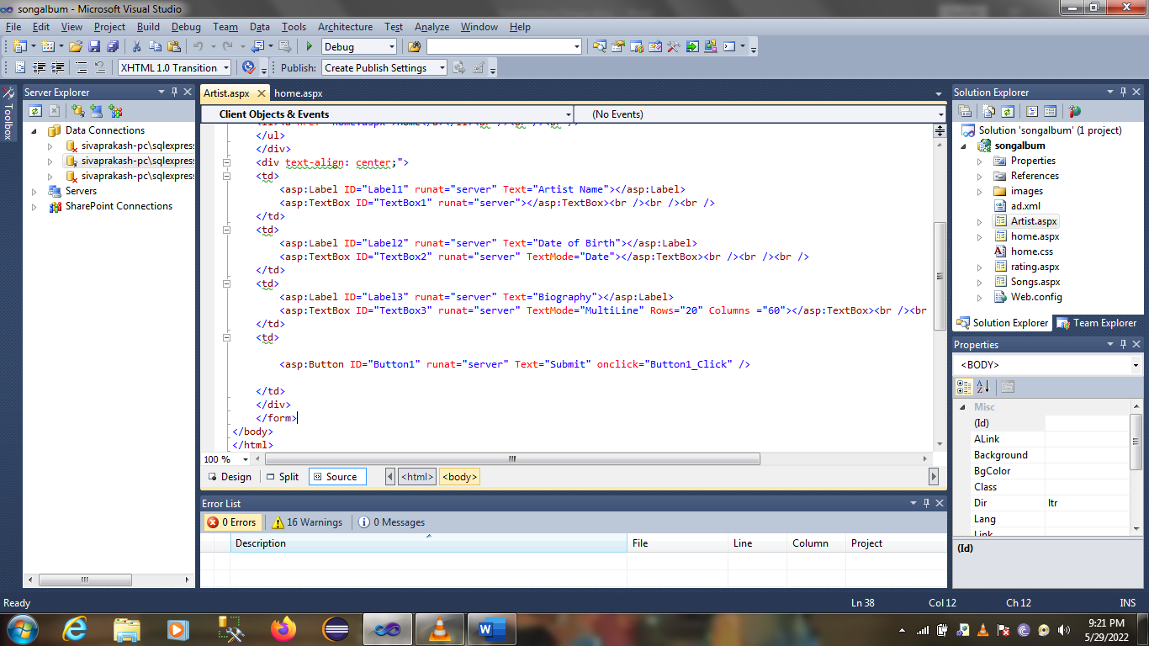

**Song page:**

Song page codes are given below with the screenshot.

<%@ Page Language="C#" AutoEventWireup="true" CodeBehind="Songs.aspx.cs" Inherits="songalbum.Songs" %>

<!DOCTYPE html PUBLIC "-//W3C//DTD XHTML 1.0 Transitional//EN" "http://www.w3.org/TR/xhtml1/DTD/xhtml1-transitional.dtd">

<html xmlns="http://www.w3.org/1999/xhtml">

<head runat="server">

<title></title>

<link href="home.css" rel="stylesheet" type="text/css" />

</head>

<body>

<div class="jumbotron text-center">

<h1>Adding Songs</h1>

</div>

<form id="form1" runat="server">

<div id = "menu">

<ul>

<li><a href="home.aspx">Home</a></li><br /><br /><br />

</ul>

</div>

<div>

<td>

<asp:Label ID="Label1" runat="server" Text="Song Name"></asp:Label>

<asp:TextBox ID="TextBox1" runat="server"></asp:TextBox><br /><br /><br />

</td>

<td>

<asp:Label ID="Label2" runat="server" Text="Date Of Released"></asp:Label>

<asp:TextBox ID="TextBox2" runat="server" TextMode="Date"></asp:TextBox><br /><br /><br />

</td>

<td>

<asp:Label ID="Label3" runat="server" Text="Cover Photo"></asp:Label>

<asp:FileUpload ID="FileUpload1" runat="server" /><br /><br /><br />

<asp:Button ID="Button1" runat="server" Text="Submit" onclick="Button1_Click" style="height: 26px"/>

</td>

</div>

</form>

</body>

</html>

**Screenshots:**

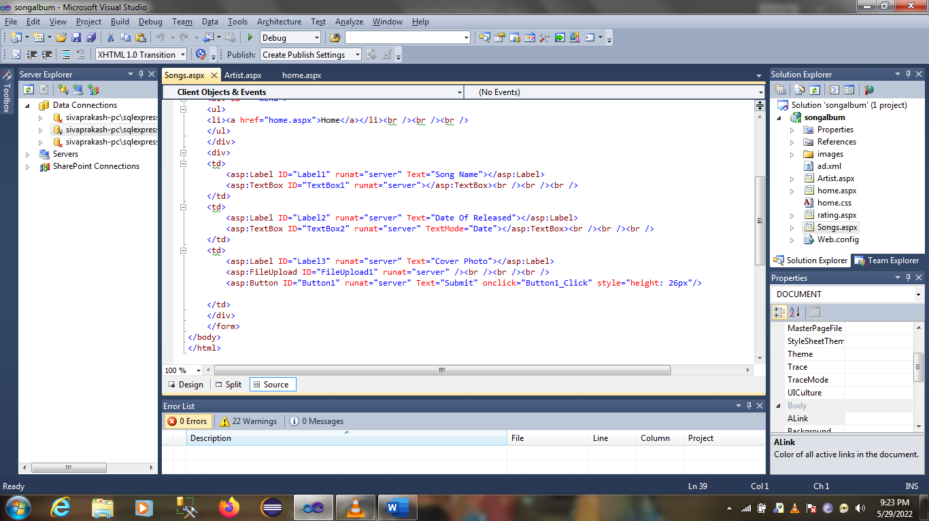

**User page:**

Artist page codes are given below with the screenshot.

<%@ Page Language="C#" AutoEventWireup="true" CodeBehind="rating.aspx.cs" Inherits="songalbum.rating" %>

<!DOCTYPE html PUBLIC "-//W3C//DTD XHTML 1.0 Transitional//EN" "http://www.w3.org/TR/xhtml1/DTD/xhtml1-transitional.dtd">

<html xmlns="http://www.w3.org/1999/xhtml">

<head id="Head1" runat="server">

<link href="home.css" rel="stylesheet" type="text/css" />

</head>

<body>

<div class="jumbotron text-center">

<h1> User Rating</h1>

<body>

<form id="form1" runat="server">

<div id = "menu">

<ul>

<li><a href="home.aspx">Home</a></li><br /><br /><br />

</ul>

</div>

<div>

<asp:Label ID="Label1" runat="server" Text="User Mailid"></asp:Label>

<asp:TextBox ID="TextBox1" runat="server" TextMode="Email"></asp:TextBox><br /><br /><br />

</div>

<div>

<asp:Label ID="Label3" runat="server" Text="Song Name"></asp:Label>

<asp:DropDownList ID="DropDownList1" runat="server">

</asp:DropDownList><br /><br /><br />

</div>

<div>

<asp:Label ID="Label2" runat="server" Text="Rating"></asp:Label>

<input name="rating_star" type="radio" class="rating_star" value="1" />

<input name="rating_star" type="radio" class="rating_star" value="2" />

<input name="rating_star" type="radio" class="rating_star" value="3" />

<input name="rating_star" type="radio" class="rating_star" value="4" />

<input name="rating_star" type="radio" class="rating_star" value="5" /><br /><br /><br />

</div>

<div>

<asp:Button ID="Button1" runat="server" Text="Submit" onclick="Button1_Click" />

</div>

</form>

</body>

</html>

**Screenshot:**

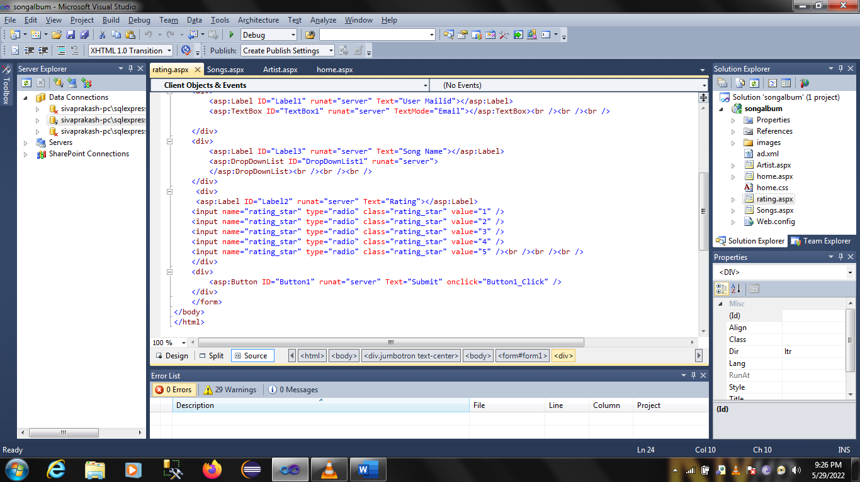

**Home.CSS:**

Home css code are given below with the screenshoot

body {

}

*

{

margin:0px;

padding:0px;

}

#menu ul

{

list-style:none;

}

#menu ul li

{

background-color:Yellow;

border:solid 1px white;

width:120px;

height:35px;

text-align:center;

line-height:35px;

float:left;

position:relative;

}

#menu ul li a

{

text-decoration:none;

color:Black;

display:block;

}

#menu ul li a:hover

{

background-color:Purple;

color:Red;

}

#menu ul ul

{

position:absolute;

display:none;

}

#menu ul li > ul li

{

background-color:Fuchsia;

color:Lime;

border:solid:1px white;

}

#menu ul li:hover > ul

{

display:block;

border-radius:10px;

}

**Screenshoots:**

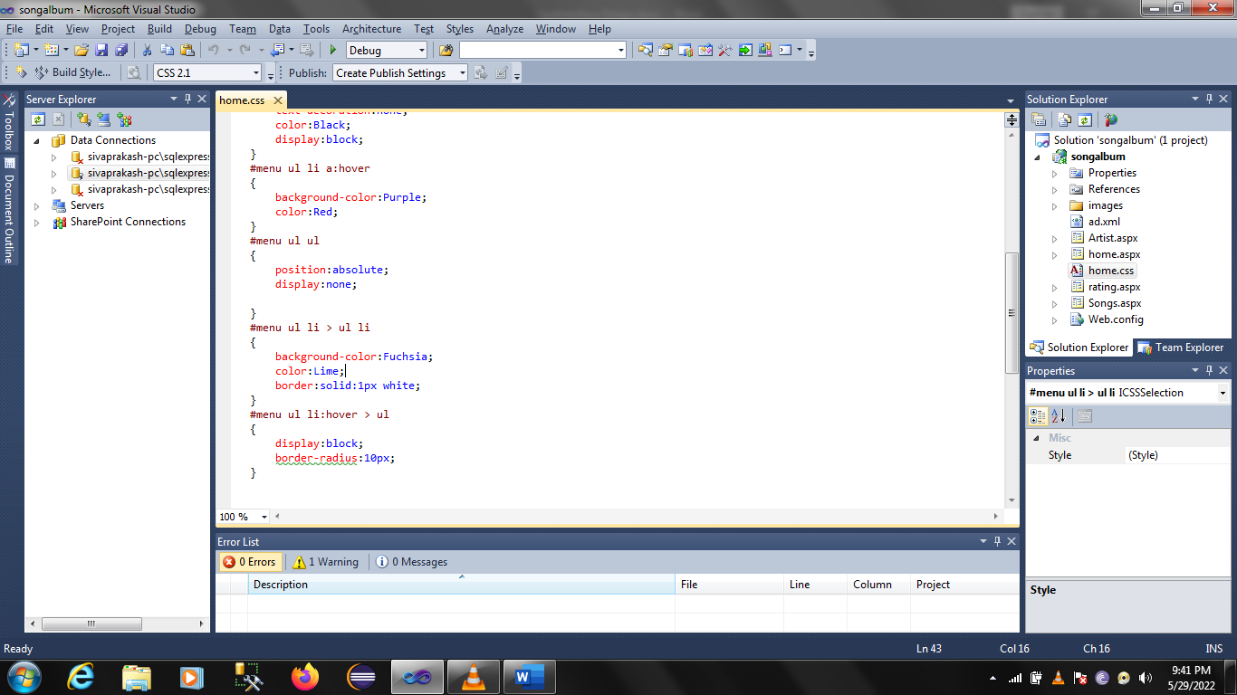

AD.XML

<Advertisements>

<Ad>

<ImageUrl>/images/1.jpg</ImageUrl>

</Ad>

<Ad>

<ImageUrl>/images/2.jpg</ImageUrl>

</Ad>

<Ad>

<ImageUrl>/images/3.jpg</ImageUrl>

</Ad>

<Ad>

<ImageUrl>/images/4.jpg</ImageUrl>

</Ad>

</Advertisements>